How to interface keypad with 8051 microcontroller (AT89C51)
Keypad is a widely used input device with lots of application in our everyday life. From a simple telephone to keyboard of a computer, ATM, electronic lock, etc., keypad is used to take input from the user for further processing. In this article we are interfacing keypad with the MCU AT89C51 and displaying the corresponding number on LCD. This module can be further used in a number of systems to interfaced keypad with microcontroller and other processors to get desired output. The program to interface keypad with controller is written in C language which is very easy to understand.
Keypad is organized as a matrix of switches in rows and column. The article uses a 4X3 matrix keypad and a 16x2 LCD for displaying the output of keypad.
The circuit diagram shows the connection of keypad with the controller. Port P2 of the microcontroller is used to send the data for displaying on the LCD. P1^1, P1^2, P1^3 pins of microcontroller is connected to RS, RW, EN pins of LCD respectively. Port P0 is used to scan input from the keypad (refer circuit diagram for connection).

The concept of interfacing keypad with the MCU is simple. Every number is assigned two unique parameters, i.e., row and column number (n(R, C) for example 6 (2, 3)). Hence every time a key is pressed the number is identified by detecting the row and column number of the key pressed.

Initially all the rows are set to zero by the controller and the columns are scanned to check if any key is pressed. In case no key is pressed the output of all the columns will be high.

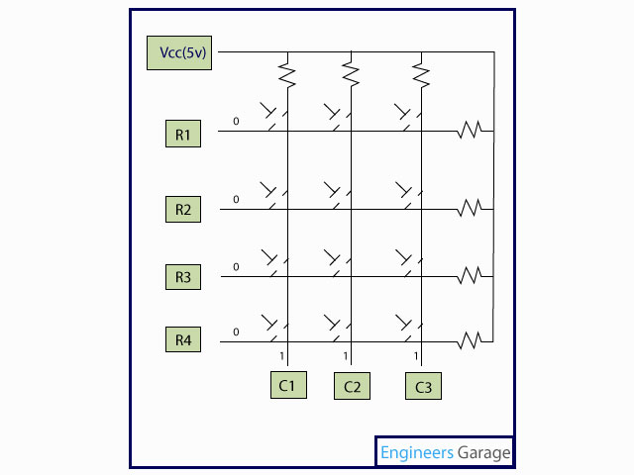

Whenever a key is pressed the row and column corresponding to the key will get short, resulting in the output of the corresponding column goes to go low (since we have made all the rows zero). This gives the column number of the pressed key.

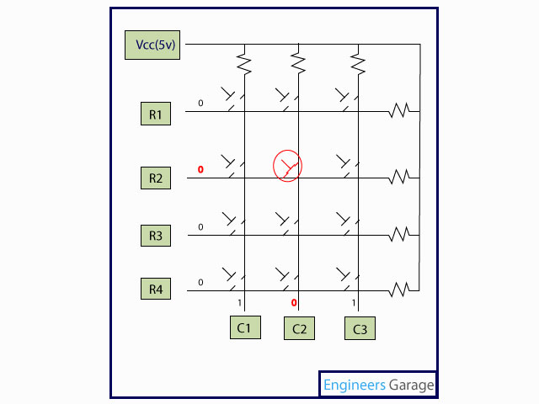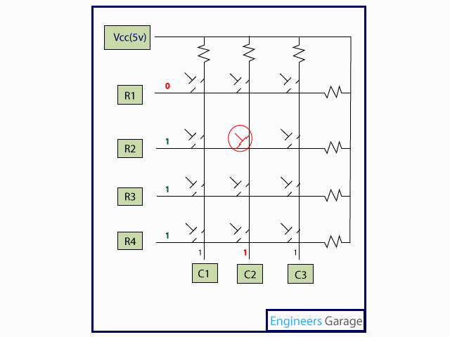
Once the column number is detected, the controller set’s all the rows to high. Now one by one each row is set to zero by controller and the earlier detected column is checked if it becomes zero. The row corresponding to which the column gets zero is the row number of the digit.

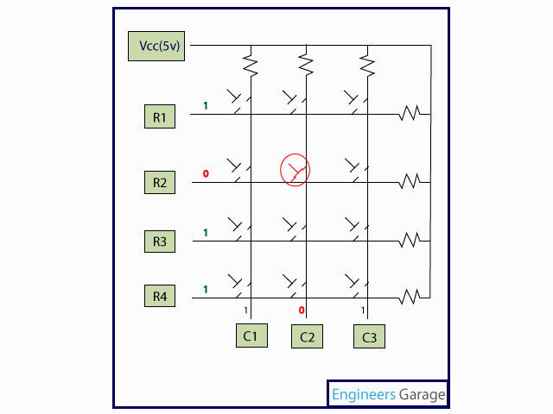

The above process is very fast and even if the switch is pressed for a very small duration of time the controller can detect the key which is pressed. The controller displays the number corresponding to the row and column on the LCD.

// Program to interface controller with controller

#include<reg51.h>
#define port P1
#define dataport P2 // Dataport for lcd
#define key P0 // Port for keypad
#define sec 100
sbit rs = port^1;
sbit rw = port^2;
sbit en = port^3;

sbit col1=key^4;
sbit col2=key^5;
sbit col3=key^6;
sbit row1=key^0;
sbit row2=key^1;
sbit row3=key^2;
sbit row4=key^3;

void delay(unsigned int msec) //Time delay function
{
int i,j ;
for(i=0;i<msec;i++)
for(j=0;j<1275;j++);
}

void lcd_cmd(unsigned char item) //Function to send command to LCD
{
dataport = item;
rs= 0;
rw=0;
en=1;
delay(1);
en=0;
return;
}

void lcd_data(unsigned char item) //Funtion to send data on LCD
{
dataport = item;
rs= 1;
rw=0;
en=1;
delay(1);
en=0;
return;
}

void lcd_data_string(unsigned char *str) // Function to send string on LCD
{
int i=0;
while(str[i]!='\0')
{
lcd_data(str[i]);
i++;
delay(10);
}
return;
}

void lcd(unsigned char str[10]) // Funtion to Initialize LCD
{
lcd_cmd(0x38);
lcd_cmd(0x0e);
//delay(sec);
lcd_cmd(0x01);
//delay(sec);
lcd_cmd(0x82);
//delay(sec);
lcd_data_string(str);
}

void display(int a) //Display function for LCD

{
switch(a)
{
case 1:lcd("one 1");
break;
case 2:lcd("two 2");
break;
case 3:lcd("three 3");
break;
case 4:lcd("four 4");
break;
case 5:lcd("five 5");
break;
case 6:lcd("six 6");
break;
case 7:lcd("seven 7");
break;
case 8:lcd("EIGHT 8");
break;
case 9:lcd("NINE 9");
break;
case 0:lcd("ZERO 0");
break;
case 11:lcd("*");
break;
case 12:lcd("#");
break;
}
}

void check_col1() //Function for checking column one
{
row1=row2=row3=row4=1;
row1=0;
if(col1==0)
display(1);
row1=1;
row2=0;
if(col1==0)
display(4);
row2=1;
row3=0;
if(col1==0)
display(7);
row3=1;
row4=0;
if(col1==0)
display(11);
row4=1;
}

void check_col2() //Function for checking column two
{
row1=row2=row3=row4=1;
row1=0;
if(col2==0)
display(2);
row1=1;
row2=0;
if(col2==0)
display(5);
row2=1;
row3=0;
if(col2==0)
display(8);
row3=1;
row4=0;
if(col2==0)
display(0);
row4=1;
}

void check_col3() //Function for checking column three
{
row1=row2=row3=row4=1;
row1=0;
if(col3==0)
display(3);
row1=1;
row2=0;
if(col3==0)
display(6);
row2=1;
row3=0;
if(col3==0)
display(9);
row3=1;
row4=0;
if(col3==0)
display(12); //For #
row4=1;
}

void main()
{
col1=col2=col3=1; //Input Port
while(1)
{
row1=row2=row3=row4=0;
if(col1==0)
check_col1();
else
if(col2==0)
check_col2();
else
if(col3==0)
check_col3();
}
}

